EX 2 MULTI-LAYER PERCEPTRON (MLP) FOR CLASSIFICATION
DATE:

Problem Statement:
Develop a Multi-Layer Perceptron (MLP) for a simple classification task. Experiment with different numbers of hidden layers and activation functions, and evaluate the model’s performance using accuracy and loss.
Suggested Dataset: Iris Dataset Objectives:
- Understand the structure and purpose of MLPs for classification.
- Experiment with various hidden layer configurations and activation functions.
- Train the MLP using the Iris dataset and evaluate its accuracy and loss.
- Visualize training progress and use the trained model for prediction.
Scope:
This experiment provides insights into how neural networks with multiple layers (MLPs) perform on structured classification tasks. It demonstrates model tuning using different architectures and activation functions, an essential concept in designing effective deep learning models.
Tools and Libraries Used:
- Python 3.x
- TensorFlow / Keras
- scikit-learn (for data preprocessing and dataset loading)
- Matplotlib (for visualization)

Implementation Steps:
Step 1: Import Necessary Libraries
import matplotlib.pyplot as plt
import numpy as np
from sklearn.datasets import load_iris
from sklearn.model_selection import train_test_split from sklearn.preprocessing import StandardScaler, OneHotEncoder from tensorflow.keras.models import Sequential from tensorflow.keras.layers import Dense

Step 2: Load and Preprocess Data
iris = load_iris() X = iris.data
y = iris.target.reshape(-1, 1)
classes = iris.target_names

encoder = OneHotEncoder(sparse_output=False) y_encoded = encoder.fit_transform(y)

scaler = StandardScaler()
X_scaled = scaler.fit_transform(X)

X_train, X_test, y_train, y_test = train_test_split(X_scaled, y_encoded, test_size=0.2, random_state=42)

Step 3: Define MLP Model Creation Function
def create_mlp(input_dim, output_dim, hidden_layers, activation='relu'):
model = Sequential() model.add(Dense(hidden_layers[0], input_dim=input_dim, activation=activation)) for units in hidden_layers[1:]:
model.add(Dense(units, activation=activation)) model.add(Dense(output_dim, activation='softmax')) model.compile(optimizer='adam', loss='categorical_crossentropy', metrics=['accuracy']) return model

Step 4: Train and Evaluate MLP with Various Configurations
hidden_layer_configs = [[8], [16, 8], [32, 16, 8]] activations = ['relu', 'tanh', 'sigmoid']

for hidden_layers in hidden_layer_configs: for activation in activations:
print(f"\nTesting MLP with hidden_layers={hidden_layers}, activation={activation}") model = create_mlp(input_dim=4, output_dim=3, hidden_layers=hidden_layers, activation=activation) history = model.fit(X_train, y_train, epochs=50, batch_size=5, verbose=0, validation_split=0.1) test_loss, test_acc = model.evaluate(X_test, y_test, verbose=0) print(f"Test Accuracy: {test_acc:.4f}, Test Loss: {test_loss:.4f}")

Step 5: Plot Accuracy and Loss Curves
# Plot accuracy and loss plt.figure(figsize=(10, 4)) plt.suptitle(f"Config: {hidden_layers}, Activation: {activation}", fontsize=14)

plt.subplot(1, 2, 1) plt.plot(history.history['accuracy'], label='Train Acc') plt.plot(history.history['val_accuracy'], label='Val Acc') plt.xlabel('Epoch') plt.ylabel('Accuracy')
plt.title('Model Accuracy')
plt.legend()

plt.subplot(1, 2, 2) plt.plot(history.history['loss'], label='Train Loss') plt.plot(history.history['val_loss'], label='Val Loss') plt.xlabel('Epoch') plt.ylabel('Loss') plt.title('Model Loss') plt.legend()

plt.tight_layout()
plt.show()

Step 6: Predict on New Input
sepal_length = float(input("Sepal length (cm): ")) sepal_width = float(input("Sepal width (cm): ")) petal_length = float(input("Petal length (cm): ")) petal_width = float(input("Petal width (cm): "))

user_input = np.array([[sepal_length, sepal_width, petal_length, petal_width]]) user_input_scaled = scaler.transform(user_input)

# Predict using the last trained model prediction = model.predict(user_input_scaled) predicted_class_index = np.argmax(prediction) predicted_class_name = classes[predicted_class_index]

print(f"\n🌸 Predicted Iris Species: {predicted_class_name}")

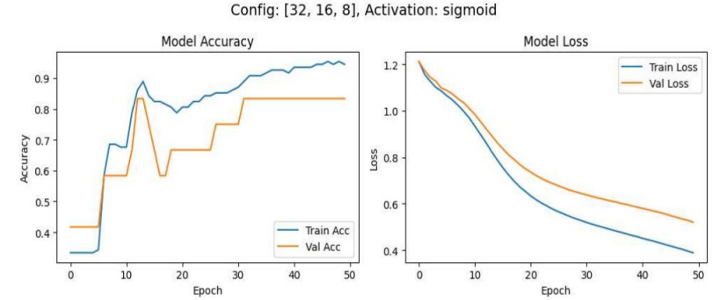

Conclusion:
This experiment demonstrates the use of MLPs for a multi-class classification problem using the Iris dataset. Through experimentation with different hidden layer depths and activation functions, students gain a practical understanding of neural network design and optimization techniques.

